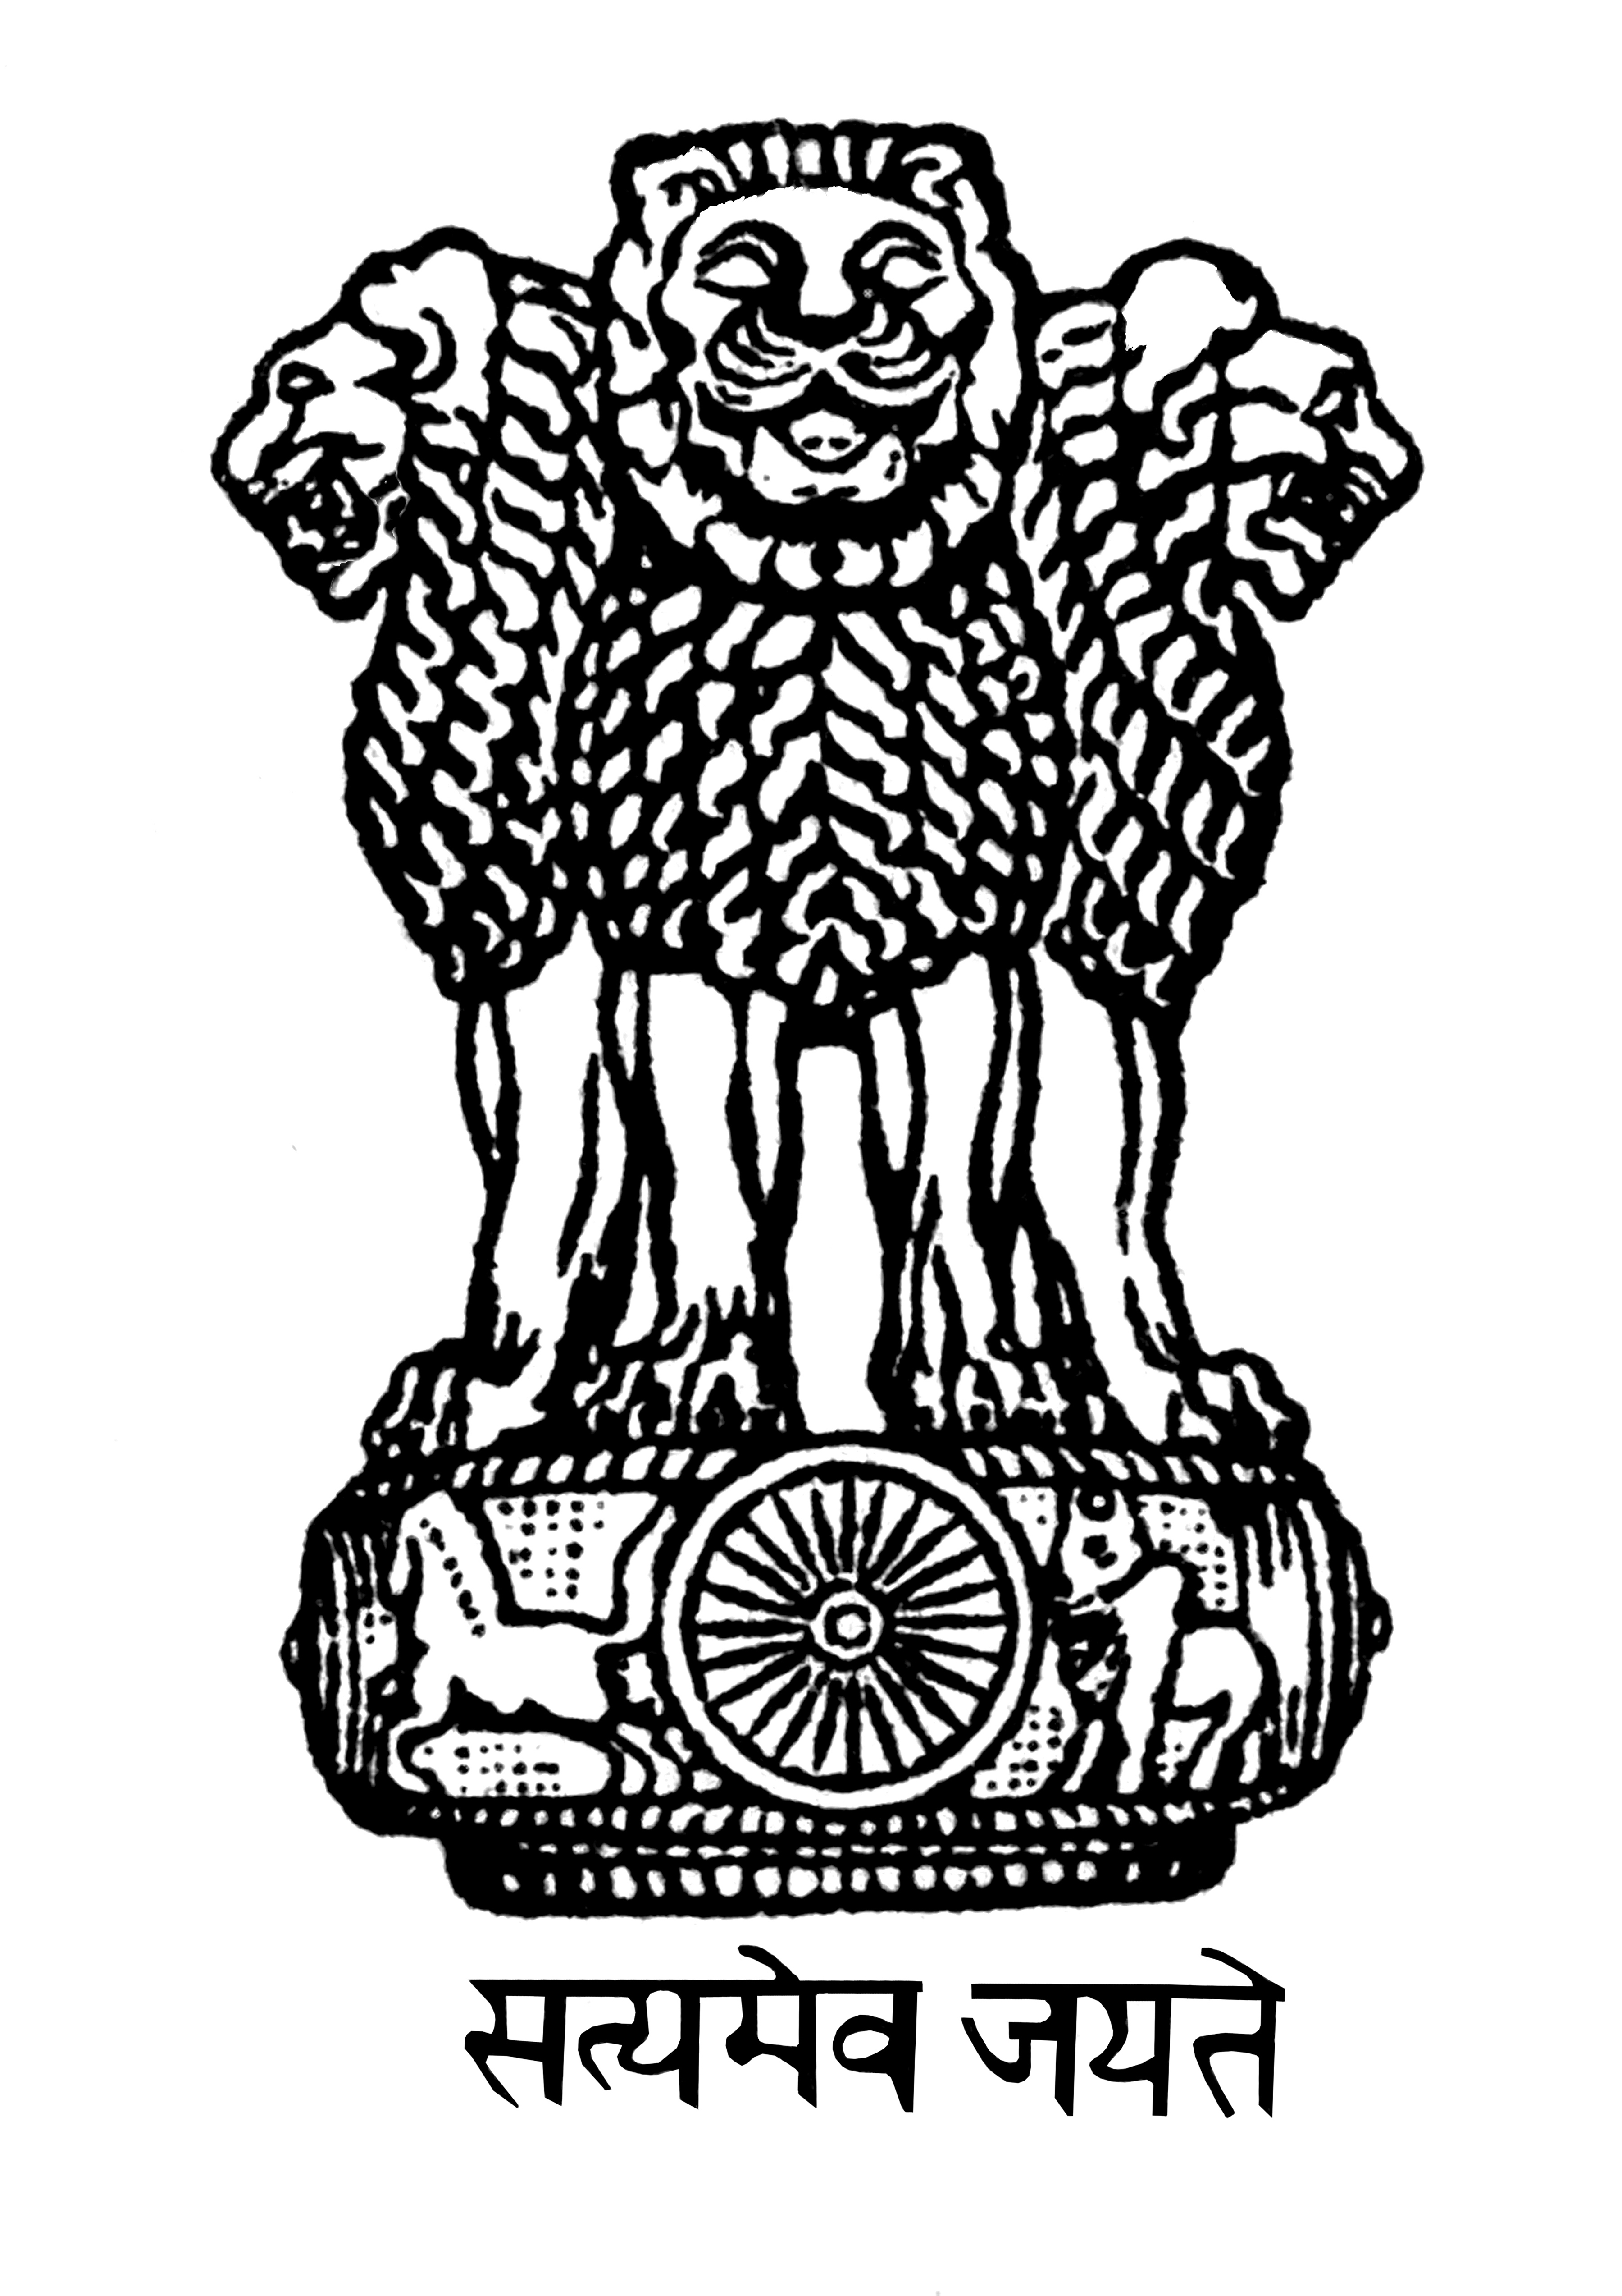

**EMBASSY OF INDIA**

**MINSK**

**PRESS RELEASE**

**CELEBRATION OF SECOND INTERNATIONAL DAY OF YOGA IN MINSK (BELARUS)**

The Embassy of India in Minsk, with the support of Minsk City Executive Committee, Government of the Republic of Belarus, organized the Second International Day of Yoga (IDY) in Gorki Park, Minsk on June 19, 2016.

The programme began at 0930 hrs. with short speeches by Ambassador and UNDP Resident Representative in Minsk, followed by Pranayam, Meditation, Surya Namaskar, various Asanas, and ended with Shavasan and display of acro-yogic exercises. Nine Yoga Groups from Minsk City were brought together to conduct the event.

Around 500-600 Yoga practitioners, representing various age-groups and nationalities, enthusiastically participated in the celebration. The Ambassadors of Italy and Syria, Cd’A of Iraq and diplomats from Czech Republic, Israel and others were also present.

Following are the links to the coverage in the local media and few photos of the event.

<http://news.tut.by/society/501159.html>

<http://sputnik.by/photo/20160619/1023422552.html>

<http://www.belta.by/sport/view/fotoreportazh-mezhdunarodnyj-den-jogi-otprazdnovali-v-minskom-parke-im-gorkogo-198120-2016/>

22 June 2016

